SANGINITA CHECMIALS LIMITED

COMPOSITION OF BOARD
Name of the Director | DIN | Category
Mr. Gaurav Kumar Tripathi | 06372272 | Whole-time Director
Mr. Anubhav Agarwal | 02809290 | Non-Executive Non-Independent Director
Mr. Piyush Bichhoriya | 10894714 | Non-Executive Non-Independent Director
Mr. Sanmitra Trivedi | 02173317 | Independent Director
Ms. Jalpa Anand Lavingia | 07969810 | Independent Director

BRIEF PROFILE OF THE DIRECTORS

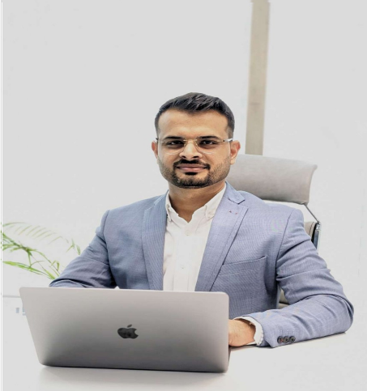Mr. Gaurav Kumar Tripathi – Whole-time Director

Mr. Gaurav Kumar Tripathi a Post graduate in management from Indian School of Business, Hyderabad and Management professional with over 17 years of experience in Business expansion strategic planning, and operational excellence across FMCG, retail, and technology sectors. He has held leadership positions with reputed organizations He has also led greenfield projects in BFSI and pharmaceutical sectors and has entrepreneurial exposure in the pharmaceutical and ethanol industries. As a people-centric leader, he focuses on building high-performance teams change management, and operational efficiency, contributing to the Company's strategic growth and expansion initiatives.

Mr. Anubhav Agarwal – Director Non-Independent

Mr. Anubhav Agarwal is an MBA-qualified and award-winning entrepreneur from a reputed business family, possessing over 15 years of extensive leadership experience in scaling and transforming businesses. He provides strategic direction, leadership, and guidance on capital allocation for the Group's business operations and diversification initiatives. His proven track record in building and managing high growth businesses continues to support the Group's long-term growth and value creation strategy.

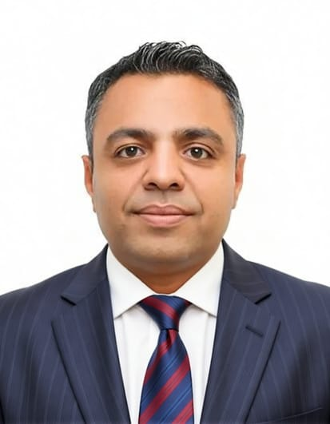 Mr. Piyush Bichhoriya – Director Non-Independent

Mr. Piyush Bichhoriya is a dynamic technology leader with over two decades of experience at t he intersection of software engineering, system optimization, and strategic business management. A graduate in Computer Science and Engineering from Nagpur University, he has consistently demonstrated a blend of technical acumen and visionary leadership in high-impact roles across Fortune 50 companies. By combining technical depth with strategic insight, he has consistently enhanced operational efficiency and delivered superior performance outcomes. Mr. Piyush's career is marked by his ability to align technical initiatives with long-term business objectives, achieving substantial returns on investment. His proven track record in cost optimization and process enhancement has set benchmarks in operational excellence. He is also adept at building and nurturing strategic partnerships, negotiating with vendors, and steering product innovation, further underscoring his strong business acumen.

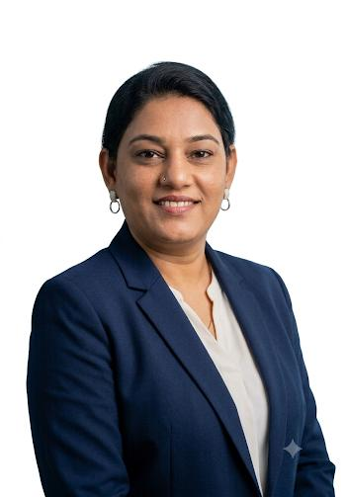Ms. Jalpa Anand Lavingia– Independent Director

Mrs. Jalpa Anand Lavingia, based in Ahmedabad, Gujarat, holds a Master's degree in Commerce (M.Com). She possesses strong communication and public speaking skills, which enable her to contribute effectively to organizational growth and operational efficiency. Her professional approach, combined with her leadership capabilities, makes her a valuable asset to the organizations with which she is associated. She had previously served as an Independent/Professional Director in different Companies:

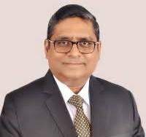 Mr. Sanmitra Trivedi – Independent Director

Mr. Sanmitra Trivedi is a qualified professional with a strong academic foundation in engineering, management, and law, holding a Bachelor of Engineering (Mechanical) from the National Institute of Technology Kamataka (NITK), along with a Post Graduate Diploma in Personnel Management & Industrial Relations and a Bachelor of Laws (LL.B.) having 30 plus years of experience. He is a distinguished senior HR executive and business leader with over three decades of CHRO level and Board-level experience across Fortune 500 multinationals and large Indian conglomerates. He had served on the Board of Directors of many reputed organizations His career spans Industrial, Oilfield Services, Refining, FinTech, Payments, Telecom, IT/ITES, and Manufacturing sectors - across India, the US, Middle East, Africa, Asia-Pacific, and Europe. .

